**FACIAL CLEANSER/WASH**

*SKIN TYPE: DRY*

(PRICES 100 - 500)

1. **Celeteque Dermo Science Hydration Facial Wash (60ml)**

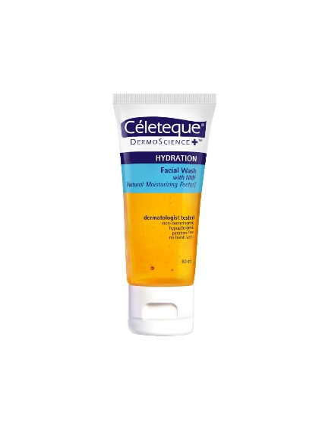

**WHAT IT DOES:** Safely removes dead skin cells that clog the pores with Dual Vitamin Nourishing Beads (Vitamins C &, E) and both antioxidants that nourishes and protects the skin.

**HOW TO USE:** Hydration Facial Wash on wet skin. Massage in a gentle circular motion. Rinse thoroughly. Use as often as needed. Use DermoScience&trade, Hydration Exfoliating Facial Wash every other day to revitalize tired-looking skin.

**PRICE:** ₱ 109.00

**BENEFICIAL INGREDIENTS:** 7/21 ingr.

**DEBATABLE INGREDIENTS:** 7/21 ingr.

1. **Neutoregena Deep Clean Gentle Foaming Cleanser (50g)**

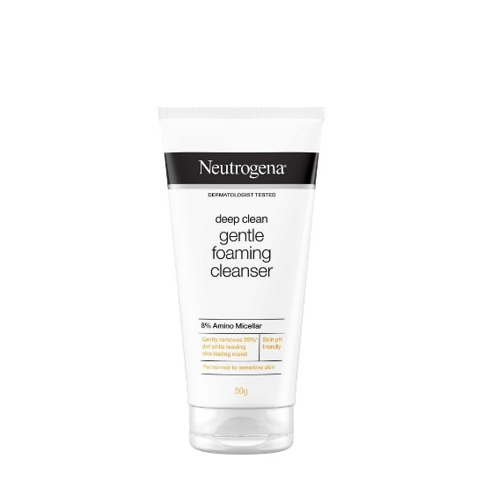

**(FOR OILY, DRY AND COMBINATION)**

**WHAT IT DOES:** Removes skin's impurities which can build up in pores such as excess oil, dirt and makeup, even stuff you don't even know is there. Helps reduce surface oil while retaining the skin's natural moisture balance to keep skin clear, fresh, and healthy looking.

**HOW TO USE:** Use twice a day. Squeeze a small amount into hands and work into a rich lather. Massage onto wet face. Avoid contact with eyes. Rinse thoroughly.

**PRICE:** ₱ 139.00

**BENEFICIAL INGREDIENTS:** 4/12 ingr.

**DEBATABLE INGREDIENTS:** 3/12 ingr.

1. **Cetaphil Gentle Skin Cleanser (60ml)**

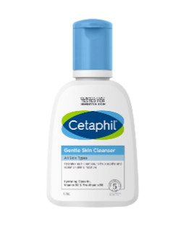

**WHAT IT DOES:** This gentle cleansing formula, now with hydrating Glycerin, Vitamin B3 & Pro-Vitamin B5, is clinically tested to be gentle at removing dirt, makeup and impurities, while preserving skin's natural moisture barrier. It's fragrance free, paraben free, non-comedogenic, and hypoallergenic.

**HOW TO USE:** With water: Apply cleanser and gentle massage into skin. Rinse, if without water: Apply a liberal amount of cleanser and gently massage into skin.

**PRICE:** ₱ 172.00

**BENEFICIAL INGREDIENTS**: 5/10 ingr.

**DEBATABLE INGREDIENTS**: 4/10 ingr.

(PRICES 500 - 1000)

1. **Nivea Daily Essentials Gentle Cleansing Cream Wash (350ml)**

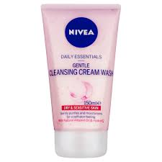

**WHAT IT DOES:** Daily Essentials Gentle Cleansing Cream Face Wash has been formulated specially for dry & sensitive skin to provide a soft and soothing effect to the skin's surface.

**HOW TO USE:** Wet face. Wet your face, neck and décolleté. Apply the cleansing cream by massaging in small upward circles avoiding the eye area. Remove and rinse cleansing cream residue off with lukewarm water.

**PRICE:** ₱ 370.44

**BENEFICIAL INGREDIENTS**: 6/25 ingr.

**DEBATABLE INGREDIENTS**: 3/25 ingr.

1. **ACNES Creamy Wash (100g)**

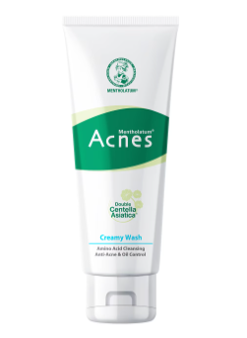

**WHAT IT DOES:** Anti-Acne & Oil Control Formulated with Salicylic Acid (BHA) to unclog pores and fight acne. Avocado extract effectively removes sebum for longer lasting oil control. Mild & Gentle to Skin  
Amino Acid soap-free formula**, close to skin's natural pH level for gentle yet effective cleansing with no tightness. Suitable for sensitive acne prone skin.

**HOW IT DOES:** Squeeze an appropriate amount into wet palms, lather with water and massage gently. Rinse thoroughly with water. Use every morning and night.

**PRICE:** ₱ 245.00

**BENEFICIAL INGREDIENTS:** 4/30 ingr.

**DEBATABLE INGREDIENTS:** 4/30 ingr.

1. **Neutrogena Hydro Boost Water Gel Cleanser (145ml)**

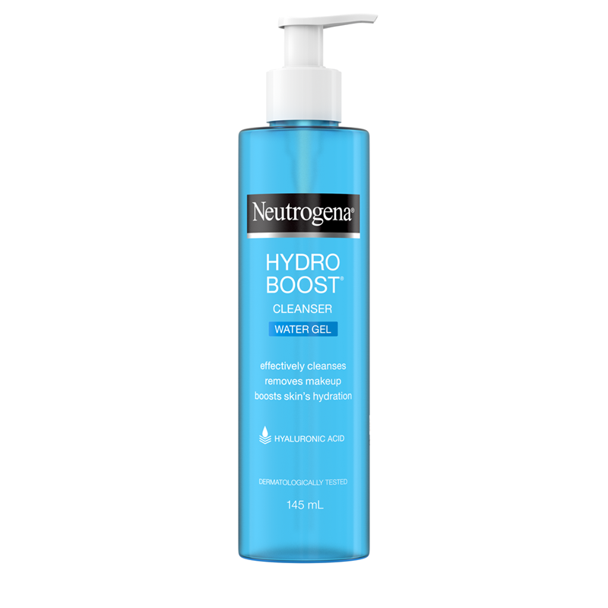

**WHAT IT DOES:** NEUTROGENA®, DEEP CLEAN®, Brightening Foaming Cleanser is an effective, deep-cleansing facial cleanser with 2X brightening power for cleaner, fairer, and more radiant skin with every wash. It contains Mulberry Extract and whitening vitamin complex that boost skin fairness with every wash. It is clinically proven formula lathers to a rich, creamy foam which removes dirt, excess oil, dead skin cells and skin dulling residue from make-up, sun-block &, BB cream., leaving your skin fair and radiant

**HOW IT DOES:** Wet face and squeeze cleanser into hand. Apply to face and massage gently. Rinse thoroughly. Avoid contact with delicate skin around eyes.

**PRICE:** ₱ 530.00

**BENEFICIAL INGREDIENTS:** 3/18 ingr.

**DEBATABLE INGREDIENTS:** 3/18 ingr.

(PRICES 1000 above)

1. **Cerave Hydrating Facial Cleanser (237ml)**

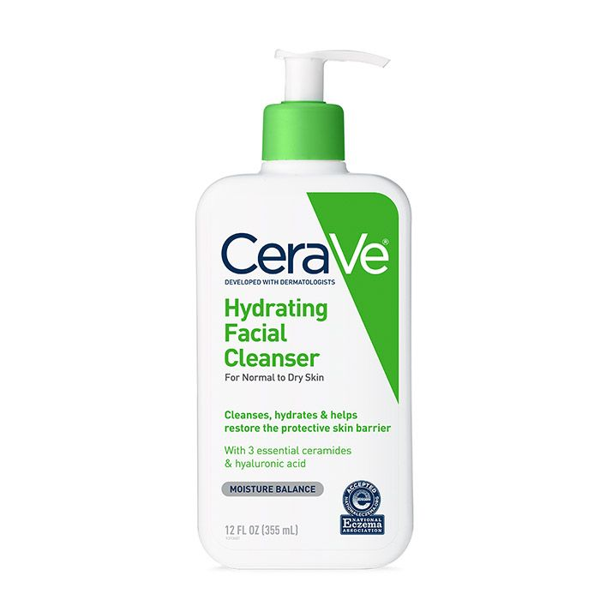

**WHAT IT DOES:** CeraVe Hydrating Cleanser was designed to cleanse and refresh the skin without over-stripping it or leaving it feeling tight and dry. Featuring three essential ceramides to restore the skin’s barrier, hyaluronic acid to hydrate the skin, and MVE Delivery Technology to supply the skin with a steady stream of nourishment, this non-comedogenic face wash is an effective yet non-irritating way to start off any skincare regimen. Best for normal to dry skin.

**HOW TO USE:** Wet skin with lukewarm water Massage cleanser into skin in a gentle, circular motion and rinse

**PRICES:** ₱ 1,250

**BENEFICIAL INGREDIENTS:** 6/21 ingr.

**DEBATABLE INGREDIENTS:** 2/21 ingr.

1. **Sunday Riley Ceramic Slip Cleanser (5fl oz)**

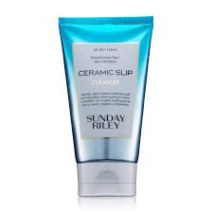

**WHAT IT DOES:** A blend of 4 gentle, plant-based soaps that lift up & wash away dirt & impurities without stripping the skin. French Green Clay pulls dirt, oil, pollution, & makeup out of pores. This gentle cleanser pulls out impurities for smaller-looking pores and a clean, radiant complexion.

**HOW TO USE:** Massage Ceramic Slip into the skin to remove dirt, oil, pollution and makeup. Rinse with warm water. Can be used morning & night.

**PRICE:** ₱ 1,939

**BENEFICIAL INGREDIENTS:** 4/27 ingr.

**DEBATABLE INGREDIENTS:** 1/27 ingr.

1. **Sulwhasoo Gentle Cleansing Foam: Nutrient-rich Lather for Skin Comforting Pore Cleansing (6.76fl oz)**

**WHAT IT DOES:** This gentle gel cleansing foam infused with nutrient-rich botanicals removes makeup and dirt while delivering comforting hydration. Rinse away leaving skin feeling soft, smooth, supple and refreshed.

**HOW TO USE:** AM and PM: add water and massage luxurious emollient foam over face then rinse. Pro tip: Use Cleansing Oil first.

**PRICE:** ₱ 2, 105.35

**BENEFICIAL INGREDIENTS:** 4/27 ingr.

**DEBATABLE INGREDIENTS:** 1/27 ingr.